Dynamics
WHEREAS KINEMATICS IS THE STUDY OF objects in motion, dynamics is the study of the causes of motion. In other words, kinematics covers the “what” of motion, while dynamics covers the “how” and “why.” Forces are the lifeblood of dynamics: objects move and change their motion under the influence of different forces. Our main emphasis will be on Newton’s three laws, which succinctly summarize everything you need to know about dynamics.
Dynamics questions on SAT II Physics often call upon your knowledge of kinematics and vectors, but these questions will probably be simpler than the problems you’ve encountered in your physics class. Because you won’t be asked to do any math that would require a calculator, you should focus on mastering the concepts that lie behind the math.

What Are Forces?
Whenever we lift something, push something, or otherwise manipulate an object, we are exerting a force. A force is defined very practically as a push or a pull—essentially it’s what makes things move. A force is a vector quantity, as it has both a magnitude and a direction.
In this chapter, we will use the example of pushing a box along the floor to illustrate many concepts about forces, with the assumption that it’s a pretty intuitive model that you will have little trouble imagining.
Physicists use simple pictures called free-body diagrams to illustrate the forces acting on an object. In these diagrams, the forces acting on a body are drawn as vectors originating from the center of the object. Following is a free-body diagram of you pushing a box into your new college dorm with force F.
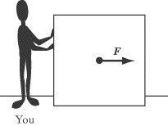
Because force is a vector quantity, it follows the rules of vector addition. If your evil roommate comes and pushes the box in the opposite direction with exactly the same magnitude of force (force –F), the net force on the box is zero
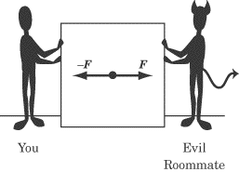

Newton’s Laws
Isaac Newton first published his three laws of motion in 1687 in his monumental Mathematical Principles of Natural Philosophy. In these three simple laws, Newton sums up everything there is to know about dynamics. This achievement is just one of the many reasons why he is considered one of the greatest physicists in history.
While a multiple-choice exam can’t ask you to write down each law in turn, there is a good chance you will encounter a problem where you are asked to choose which of Newton’s laws best explains a given physical process. You will also be expected to make simple calculations based on your knowledge of these laws. But by far the most important reason for mastering Newton’s laws is that, without them, thinking about dynamics is impossible. For that reason, we will dwell at some length on describing how these laws work qualitatively.
Newton’s First Law
Newton’s First Law describes how forces relate to motion:
An object at rest remains at rest, unless acted upon by a net force. An object in motion remains in motion, unless acted upon by a net force.
A soccer ball standing still on the grass does not move until someone kicks it. An ice hockey puck will continue to move with the same velocity until it hits the boards, or someone else hits it. Any change in the velocity of an object is evidence of a net force acting on that object. A world without forces would be much like the images we see of the insides of spaceships, where astronauts, pens, and food float eerily about.
Remember, since velocity is a vector quantity, a change in velocity can be a change either in the magnitude or the direction of the velocity vector. A moving object upon which no net force is acting doesn’t just maintain a constant speed—it also moves in a straight line.
But what does Newton mean by a net force? The net force is the sum of the forces acting on a body. Newton is careful to use the phrase “net force,” because an object at rest will stay at rest if acted upon by forces with a sum of zero. Likewise, an object in motion will retain a constant velocity if acted upon by forces with a sum of zero.
Consider our previous example of you and your evil roommate pushing with equal but opposite forces on a box. Clearly, force is being applied to the box, but the two forces on the box cancel each other out exactly: F + –F = 0. Thus the net force on the box is zero, and the box does not move.
Yet if your other, good roommate comes along and pushes alongside you with a force R, then the tie will be broken and the box will move. The net force is equal to:
Note that the acceleration, a, and the velocity of the box, v, is in the same direction as the net force.
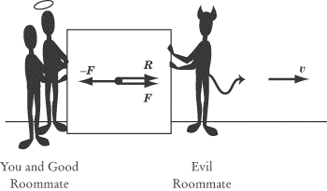
Inertia
The First Law is sometimes called the law of inertia. We define inertia as the tendency of an object to remain at a constant velocity, or its resistance to being accelerated. Inertia is a fundamental property of all matter and is important to the definition of mass.
Newton’s Second Law
To understand Newton’s Second Law, you must understand the concept of mass. Mass is an intrinsic scalar quantity: it has no direction and is a property of an object, not of the object’s location. Mass is a measurement of a body’s inertia, or its resistance to being accelerated. The words mass and matter are related: a handy way of thinking about mass is as a measure of how much matter there is in an object, how much “stuff” it’s made out of. Although in everyday language we use the words massand weight interchangeably, they refer to two different, but related, quantities in physics. We will expand upon the relation between mass and weight later in this chapter, after we have finished our discussion of Newton’s laws.
We already have some intuition from everyday experience as to how mass, force, and acceleration relate. For example, we know that the more force we exert on a bowling ball, the faster it will roll. We also know that if the same force were exerted on a basketball, the basketball would move faster than the bowling ball because the basketball has less mass. This intuition is quantified in Newton’s Second Law:
Stated verbally, Newton’s Second Law says that the net force, F, acting on an object causes the object to accelerate, a. Since F = ma can be rewritten as a = F/m, you can see that the magnitude of the acceleration is directly proportional to the net force and inversely proportional to the mass, m. Both force and acceleration are vector quantities, and the acceleration of an object will always be in the same direction as the net force.
The unit of force is defined, quite appropriately, as a newton (N). Because acceleration is given in units of m/s2 and mass is given in units of kg, Newton’s Second Law implies that 1 N = 1 kg · m/s2. In other words, one newton is the force required to accelerate a one-kilogram body, by one meter per second, each second.
Newton’s Second Law in Two Dimensions
With a problem that deals with forces acting in two dimensions, the best thing to do is to break each force vector into its x- and y-components. This will give you two equations instead of one:

The component form of Newton’s Second Law tells us that the component of the net force in the direction is directly proportional to the resulting component of the acceleration in the direction, and likewise for the y-component.
Newton’s Third Law
Newton’s Third Law has become a cliché. The Third Law tells us that:
To every action, there is an equal and opposite reaction.
What this tells us in physics is that every push or pull produces not one, but two forces. In any exertion of force, there will always be two objects: the object exerting the force and the object on which the force is exerted. Newton’s Third Law tells us that when object A exerts a force F on object B, object B will exert a force –F on object A. When you push a box forward, you also feel the box pushing back on your hand. If Newton’s Third Law did not exist, your hand would feel nothing as it pushed on the box, because there would be no reaction force acting on it.
Anyone who has ever played around on skates knows that when you push forward on the wall of a skating rink, you recoil backward.
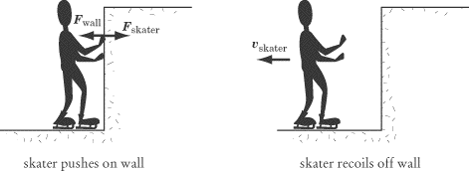
Newton’s Third Law tells us that the force that the skater exerts on the wall, , is exactly equal in magnitude and opposite in direction to the force that the wall exerts on the skater, . The harder the skater pushes on the wall, the harder the wall will push back, sending the skater sliding backward.
Newton’s Third Law at Work
Here are three other examples of Newton’s Third Law at work, variations of which often pop up on SAT II Physics:
You push down with your hand on a desk, and the desk pushes upward with a force equal in magnitude to your push.
A brick is in free fall. The brick pulls the Earth upward with the same force that the Earth pulls the brick downward.
When you walk, your feet push the Earth backward. In response, the Earth pushes your feet forward, which is the force that moves you on your way.
The second example may seem odd: the Earth doesn’t move upward when you drop a brick. But recall Newton’s Second Law: the acceleration of an object is inversely proportional to its mass (a = F/m). The Earth is about 1024 times as massive as a brick, so the brick’s downward acceleration of –9.8 m/s2 is about 1024 times as great as the Earth’s upward acceleration. The brick exerts a force on the Earth, but the effect of that force is insignificant.

Problem Solving with Newton’s Laws
Dynamics problem solving in physics class usually involves difficult calculations that take into account a number of vectors on a free-body diagram. SAT II Physics won’t expect you to make any difficult calculations, and the test will usually include the free-body diagrams that you need. Your task will usually be to interpret free-body diagrams rather than to draw them.
EXAMPLE 1
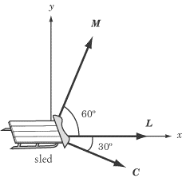
The Three Stooges are dragging a 10 kg sled across a frozen lake. Moe pulls with force M, Larry pulls with force L, and Curly pulls with force C. If the sled is moving in the direction, and both Moe and Larry are exerting a force of 10 N, what is the magnitude of the force Curly is exerting? Assuming that friction is negligible, what is the acceleration of the sled? (Note: sin 30 = cos 60 = 0.500 and sin 60 = cos 30 = 0.866.)

The figure above gives us a free-body diagram that shows us the direction in which all forces are acting, but we should be careful to note that vectors in the diagram are not drawn to scale: we cannot estimate the magnitude of C simply by comparing it to M and L.
What is the magnitude of the force Curly is exerting?
Since we know that the motion of the sled is in the direction, the net force, M + L + C, must also be in the direction. And since the sled is not moving in the direction, the y-component of the net force must be zero. Because the y-component of Larry’s force is zero, this implies:
where is the y-component of M and is the y-component of C. We also know:
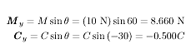
If we substitute these two equations for and into the equation , we have:

What is the acceleration of the sled?
According to Newton’s Second Law, the acceleration of the sled is a = F/m. We know the sled has a mass of 10 kg, so we just need to calculate the magnitude of the net force in the -direction.
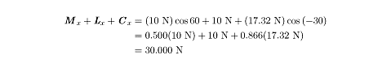
Now that we have calculated the magnitude of the net force acting on the sled, a simple calculation can give us the sled’s acceleration:

We have been told that the sled is moving in the direction, so the acceleration is also in the direction.
This example problem illustrates the importance of vector components. For the SAT II, you will need to break vectors into components on any problem that deals with vectors that are not all parallel or perpendicular. As with this example, however, the SAT II will always provide you with the necessary trigonometric values.
EXAMPLE 2
Each of the following free-body diagrams shows the instantaneous forces, F, acting on a particle and the particle’s instantaneous velocity, v. All forces represented in the diagrams are of the same magnitude.
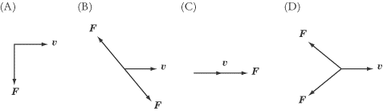

1. | In which diagram is neither the speed nor the direction of the particle being changed?

2. | In which diagram is the speed but not the direction of the particle being changed?

3. | In which diagram is the direction but not the speed of the particle being changed?

4. | In which diagram are both the speed and direction of the particle being changed?

The answer to question 1 is B. The two forces in that diagram cancel each other out, so the net force on the particle is zero. The velocity of a particle only changes under the influence of a net force. The answer to question 2 is C. The net force is in the same direction as the particle’s motion, so the particle continues to accelerate in the same direction. The answer to question 3 is A. Because the force is acting perpendicular to the particle’s velocity, it does not affect the particle’s speed, but rather acts to pull the particle in a circular orbit. Note, however, that the speed of the particle only remains constant if the force acting on the particle remains perpendicular to it. As the direction of the particle changes, the direction of the force must also change to remain perpendicular to the velocity. This rule is the essence of circular motion, which we will examine in more detail later in this book. The answer to question 4 is D. The net force on the particle is in the opposite direction of the particle’s motion, so the particle slows down, stops, and then starts accelerating in the opposite direction.

Types of Forces
There are a number of forces that act in a wide variety of cases and have been given specific names. Some of these, like friction and the normal force, are so common that we’re hardly aware of them as distinctive forces. It’s important that you understand how and when these forces function, because questions on SAT II Physics often make no mention of them explicitly, but expect you to factor them into your calculations. Some of these forces will also play an important role in the chapter on special problems in mechanics.
Weight
Although the words weight and mass are often interchangeable in everyday language, these words refer to two different quantities in physics. The mass of an object is a property of the object itself, which reflects its resistance to being accelerated. The weight of an object is a measure of the gravitational force being exerted upon it, and so it varies depending on the gravitational force acting on the object. Mass is a scalar quantity measured in kilograms, while weight is a vector quantity measuring force, and is represented in newtons. Although an object’s mass never changes, its weight depends on the force of gravity in the object’s environment.
For example, a 10 kg mass has a different weight on the moon than it does on Earth. According to Newton’s Second Law, the weight of a 10 kg mass on Earth is

This force is directed toward the center of the Earth. On the moon, the acceleration due to gravity is roughly one-sixth that on Earth. Therefore, the weight of a 10 kg mass on the moon is only about 16.3 N toward the center of the moon.
The Normal Force
The normal force always acts perpendicular (or “normal”) to the surface of contact between two objects. The normal force is a direct consequence of Newton’s Third Law. Consider the example of a 10 kg box resting on the floor. The force of gravity causes the box to push down upon the ground with a force, W, equal to the box’s weight. Newton’s Third Law dictates that the floor must apply an equal and opposite force, N = –W, to the box. As a result, the net force on the box is zero, and, as we would expect, the box remains at rest. If there were no normal force pushing the box upward, there would be a net force acting downward on the box, and the box would accelerate downward
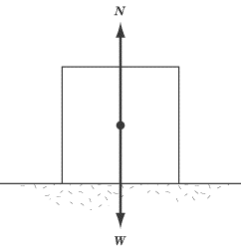
Be careful not to confuse the normal force vector N with the abbreviation for newtons, N. It can be a bit confusing that both are denoted by the same letter of the alphabet, but they are two totally different entities.
EXAMPLE
A person pushes downward on a box of weight W with a force F. What is the normal force, N, acting on the box?

The total force pushing the box toward the ground is W + F. From Newton’s Third Law, the normal force exerted on the box by the floor has the same magnitude as W + F but is directed upward. Therefore, the net force on the box is zero and the box remains at rest.
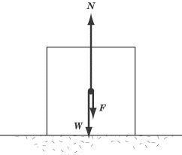
Friction
Newton’s First Law tells us that objects in motion stay in motion unless a force is acting upon them, but experience tells us that when we slide coins across a table, or push boxes along the floor, they slow down and come to a stop. This is not evidence that Newton was wrong; rather, it shows that there is a force acting upon the coin or the box to slow its motion. This is the force of friction, which is at work in every medium but a vacuum, and is the bugbear of students pushing boxes across the sticky floors of dorm rooms everywhere.
Roughly speaking, frictional forces are caused by the roughness of the materials in contact, deformations in the materials, and molecular attraction between materials. You needn’t worry too much over the causes of friction, though: SAT II Physics isn’t going to test you on them. The most important thing to remember about frictional forces is that they are always parallel to the plane of contact between two surfaces, and opposite to the direction that the object is being pushed or pulled.
There are two main types of friction: static friction and kinetic friction. Kinetic friction is the force between two surfaces moving relative to one another, whereas static friction is the force between two surfaces that are not moving relative to one another.
Static Friction
Imagine, once more, that you are pushing a box along a floor. When the box is at rest, it takes some effort to get it to start moving at all. That’s because the force of static friction is resisting your push and holding the box in place.
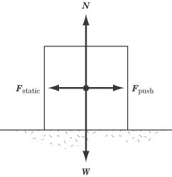
In the diagram above, the weight and the normal force are represented as W and N respectively, and the force applied to the box is denoted by . The force of static friction is represented by , where . The net force on the box is zero, and so the box does not move. This is what happens when you are pushing on the box, but not hard enough to make it budge.
Static friction is only at work when the net force on an object is zero, and hence when . If there is a net force on the object, then that object will be in motion, and kinetic rather than static friction will oppose its motion.
Kinetic Friction
The force of static friction will only oppose a push up to a point. Once you exert a strong enough force, the box will begin to move. However, you still have to keep pushing with a strong, steady force to keep it moving along, and the box will quickly slide to a stop if you quit pushing. That’s because the force of kinetic friction is pushing in the opposite direction of the motion of the box, trying to bring it to rest.
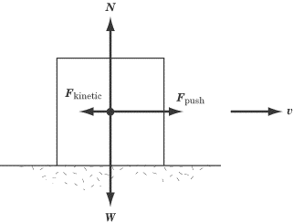
Though the force of kinetic friction will always act in the opposite direction of the force of the push, it need not be equal in magnitude to the force of the push. In the diagram above, the magnitude of is less than the magnitude of . That means that the box has a net force in the direction of the push, and the box accelerates forward. The box is moving at velocity v in the diagram, and will speed up if the same force is steadily applied to it. If were equal to , the net force acting on the box would be zero, and the box would move at a steady velocity of v, since Newton’s First Law tells us that an object in motion will remain in motion if there is no net force acting on it. If the magnitude of were less than the magnitude of , the net force would be acting against the motion, and the box would slow down until it came to a rest.
The Coefficients of Friction
The amount of force needed to overcome the force of static friction on an object, and the magnitude of the force of kinetic friction on an object, are both proportional to the normal force acting on the object in question. We can express this proportionality mathematically as follows:

where is the coefficient of kinetic friction, is the coefficient of static friction, and N is the magnitude of the normal force. The coefficients of kinetic and static friction are constants of proportionality that vary from object to object.
Note that the equation for static friction is for the maximum value of the static friction. This is because the force of static friction is never greater than the force pushing on an object. If a box has a mass of 10 kg and = 0.5, then:

If you push this box with a force less than 49 newtons, the box will not move, and consequently the net force on the box must be zero. If an applied force is less than , then = –.
Three Reminders
Whenever you need to calculate a frictional force on SAT II Physics, you will be told the value of , which will fall between 0 and 1. Three things are worth noting about frictional forces:
- The smaller µ is, the more slippery the surface. For instance, ice will have much lower coefficients of friction than Velcro. In cases where , the force of friction is zero, which is the case on ideal frictionless surfaces.
- The coefficient of kinetic friction is smaller than the coefficient of static friction. That means it takes more force to start a stationary object moving than to keep it in motion. The reverse would be illogical: imagine if you could push on an object with a force greater than the maximum force of static friction but less than the force of kinetic friction. That would mean you could push it hard enough to get it to start moving, but as soon as it starts moving, the force of kinetic friction would push it backward.
- Frictional forces are directly proportional to the normal force. That’s why it’s harder to slide a heavy object along the floor than a light one. A light coin can slide several meters across a table because the kinetic friction, proportional to the normal force, is quite small.
EXAMPLE
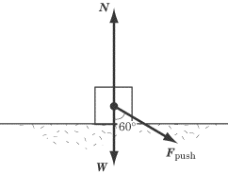
A student pushes a box that weighs 15 N with a force of 10 N at a 60Âº angle to the perpendicular. The maximum coefficient of static friction between the box and the floor is 0.4. Does the box move? Note that sin 60Âº = 0.866 and cos 60Âº = 0.500.

In order to solve this problem, we have to determine whether the horizontal component of is of greater magnitude than the maximum force of static friction.
We can break the vector into horizontal and vertical components. The vertical component will push the box harder into the floor, increasing the normal force, while the horizontal component will push against the force of static friction. First, let’s calculate the vertical component of the force so that we can determine the normal force, N, of the box:
If we add this force to the weight of the box, we find that the normal force is 15 + 5.0 = 20 N. Thus, the maximum force of static friction is:
The force pushing the box forward is the horizontal component of , which is:
As we can see, this force is just slightly greater than the maximum force of static friction opposing the push, so the box will slide forward.
Tension
Consider a box being pulled by a rope. The person pulling one end of the rope is not in contact with the box, yet we know from experience that the box will move in the direction that the rope is pulled. This occurs because the force the person exerts on the rope is transmitted to the box.
The force exerted on the box from the rope is called the tension force, and comes into play whenever a force is transmitted across a rope or a cable. The free-body diagram below shows us a box being pulled by a rope, where W is the weight of the box, N is the normal force, T is the tension force, and is the frictional force.
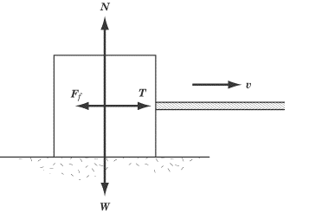
In cases like the diagram above, it’s very easy to deal with the force of tension by treating the situation just as if there were somebody behind the box pushing on it. We’ll find the force of tension coming up quite a bit in the chapter on special problems in mechanics, particularly when we deal with pulleys.

Key Formulas
Newton’s Second Law
Formula for Force of Kinetic Friction
Formula for Force of Maximum Static Friction

Practice Questions
1. | Each of the figures below shows a particle moving with velocity v, and with one or two forces of magnitude F acting upon it. In which of the figures will v remain constant?
 | (A)
 | (B)
 | (C) | 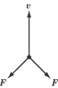
 | (D) | 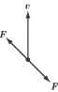
 | (E) | 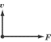

2. | In which of the following examples is a net force of zero acting on the object in question?
I. A car drives around a circular racetrack at a constant speed
II. A person pushes on a door to hold it shut
III. A ball, rolling across a grassy field, slowly comes to a stop
 | (A) | I only
 | (B) | II only
 | (C) | III only
 | (D) | I and II only
 | (E) | I and III only

3. | A force F is acting on an object of mass m to give it an acceleration of a. If m is halved and F is quadrupled, what happens to a?
 | (A) | It is divided by eight
 | (B) | It is divided by two
 | (C) | It remains unchanged
 | (D) | It is multiplied by two
 | (E) | It is multiplied by eight

4. | A force pushes on an object of mass 10 kg with a force of 5 N to the right. A force pushes on the same object with a force of 15 N to the left. What is the acceleration of the object?
 | (A) | 0.3 m/s2 to the left
 | (B) | 0.5 m/s2 to the left
 | (C) | 1 m/s2 to the left
 | (D) | 1.5 m/s2 to the left
 | (E) | 10 m/s2 to the left

 | 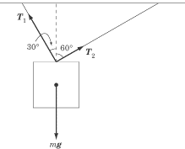
5. | In the figure above, a block is suspended from two ropes, so that it hangs motionless in the air. If the magnitude of is 10.0 N, what is the magnitude of ? Note that sin 30 = cos 60 = 0.500, and sin 60 = cos 30 = 0.866.
 | (A) | 0.433 N
 | (B) | 0.500 N
 | (C) | 0.866 N
 | (D) | 10.0 N
 | (E) | 17.3 N

 | 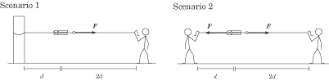
6. | In scenario 1, a person pulls with a force F on a string of length 2d that is connected to a spring scale. The other end of the spring scale is connected to a post by a string of length d. In scenario 2, the person pulls on the string of length 2d with a force of F, and a second person stands where the post was in scenario 1, and also pulls with a force of F. If the spring scale reads 50 N in scenario 1, what does the spring scale read in scenario 2?
 | (A) | 50 N
 | (B) | 67 N
 | (C) | 100 N
 | (D) | 133 N
 | (E) | 150 N

 | 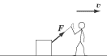
7. | In the figure above, a person is dragging a box attached to a string along the ground. Both the person and the box are moving to the right with a constant velocity, v. What horizontal forces are acting on the person?
 | (A) | The tension force in the string is pulling the person to the left
 | (B) | The tension force in the string is pulling the person to the left, and the Earth is pushing the person to the right
 | (C) | The tension force in the string is pulling the person to the left, and the Earth is pushing the person to the left
 | (D) | The tension force in the string is pushing the person to the right, and the Earth is pushing the person to the right
 | (E) | The tension force in the string is pushing the person to the right, and the Earth is pushing the person to the left

8. | What is the weight of a man whose mass is 80 kg?
 | (A) | 8.1 N
 | (B) | 70.2 N
 | (C) | 80 N
 | (D) | 89.8 N
 | (E) | 784 N

9. | A 50 kg crate rests on the floor. The coefficient of static friction is 0.5. The force parallel to the floor needed to move the crate is most nearly:
 | (A) | 25 N
 | (B) | 50 N
 | (C) | 125 N
 | (D) | 250 N
 | (E) | 500 N

10. | A person is pushing an object of mass m along the ground with a force F. The coefficient of kinetic friction between the object and the ground is . The object is accelerating, but then the person stops pushing and the object slides to a halt. The person then starts pushing on the object again with a force F, but the object doesn’t budge. The maximum coefficient of static friction between the object and the ground is . Which of the following statements is true?
 | (A) | 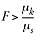
 | (B)
 | (C)
 | (D)
 | (E) | The scenario described is physically impossible

Explanations
1. D
According to Newton’s First Law, an object maintains a constant velocity if the net force acting on it is zero. Since the two forces in D cancel each other out, the net force on the particle is zero.
2. B
Newton’s First Law tells us that a net force of zero is acting on an object if that object maintains a constant velocity. The car going around the racetrack in statement I has a constant speed, but since its direction is constantly changing (as it’s going in a circle), its velocity is also changing, and so the net force acting on it isn’t zero.
The person in statement II exerts a force on the door, but neither she nor the door actually moves: the force is exerted so as to hold the door in place. If the door isn’t moving, its velocity is constant at zero, and so the net force acting on the door must also be zero.
Though no one is pushing on the soccer ball in statement III, some force must be acting on it if it slows down and comes to a stop. This is a result of the force of friction between the ball and the grass: if there were no friction, the ball would keep rolling.
Since the net force is zero only in statement II, B is the correct answer.
3. E
Newton’s Second Law tells us that F = ma. From this we can infer that a = F/m. Since F is directly proportional to a, quadrupling F will also quadruple a. And since m is inversely proportional to a, halving m will double a. We’re quadrupling a and then doubling a, which means that, ultimately, we’re multiplying a by eight.
4. C
Newton’s Second Law tells us that . The net force acting on the object is: 15 N left – 5 N right = 10 N left. With that in mind, we can simply solve for A:

5. E
Since the block is motionless, the net force acting on it must be zero. That means that the component of that pulls the block to the left must be equal and opposite to the component of that pulls the block to the right. The component pulling the block to the right is sin 60 = (0.866)(10.0 N). The component pulling the block to the left is sin 30 = 0.500 . With these components, we can solve for :

6. A
In both cases, the spring scale isn’t moving, which means that the net force acting on it is zero. If the person in scenario 1 is pulling the spring scale to the right with force F, then there must be a tension force of F in the string attaching the spring scale to the post in order for the spring scale to remain motionless. That means that the same forces are acting on the spring scale in both scenarios, so if the spring scale reads 50 N in scenario 1, then it must also read 50 N in scenario 2. Don’t be fooled by the lengths of the pieces of string. Length has no effect on the tension force in a string.
7. B
Solving this problem demands an understanding of Newton’s Third Law. Since the person exerts a force to pull the string to the right, the string must exert an equal and opposite force to pull the person to the left. Further, we know that the person moves at a constant velocity, so the net force acting on the person is zero. That means there must be a force pushing the person to the right to balance the string’s reaction force pulling to the left. That other force is the reaction force of the Earth: the person moves forward by pushing the Earth to the left, and the Earth in turn pushes the person to the right. This may sound strange, but it’s just a fancy way of saying “the person is walking to the right.”
8. E
The weight of any object is the magnitude of the force of gravity acting upon it. In the case of the man, this force has a magnitude of:

9. D
The force needed to move the crate is equal and opposite to the maximum force of static friction, , where is the coefficient of static friction. Therefore, the magnitude of the force parallel to the floor is

10. C
When the person is pushing on the moving box, the box accelerates, meaning that F is greater than the force of kinetic friction, . When the box is at rest, the person is unable to make the box move, which means that the maximum force of static friction, , is greater than or equal to F.
You may be tempted by D: the box isn’t moving, so the force of static friction perfectly balances out the pushing force exerted by the person. However, is the maximum coefficient of static friction. The force of static friction is always only enough to resist the pushing force, so it’s possible that the person could apply a greater force and still not make the object budge. Also, note that B states a physical impossibility. The coefficient of static friction is always greater than the coefficient of kinetic friction.

